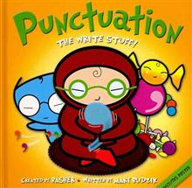

Punctuation Detectives

Enduring Understanding: Our brains are wired to listen, speak, read, and write using manmade organizational structures (ex-punctuation) so that we can communicate meaning to specific audiences for specific purposes so that we can better understand ourselves and our world now and in the future.
Essential Questions:
- How can I read, analyze, and interpret text to understand writers’ systems for the craft of punctuation so that I can make my own reading and writing decisions?
- What punctuation uses don’t fit accepted “rules” for grammar? Why? What other questions does this make you wonder?
- What tools, vocabulary, and punctuation processes are needed to create meaning?

TASK
You’ll need: Colored paper folded into sixths each section labeled (1) commas, (2) colons, (3) dashes, (4) ellipses, (5) semicolons, and (6) parentheses; handout: Punctuation Detectives.
Directions:
- (Individual) View the Punctuation Detectives Power Point. On the colored paper, for each type of punctuation, write down observations, notes, theories, patterns, etc.

- (partners small groups) On the Punctuation Detectives handout, use the notes on your colored paper to write down a job description in the “Definition” column and an easy-to-remember, catchy name that describes the job in the “Name” column.

Ensure that the definition explains all of the examples. If a punctuation mark does more than one thing, give it a separate name and definition.

Note: This assignment, along with Punctuation Theory, is required to participate in our class Socratic Seminar.

