There’s lots of room for learning
Schools reinvent classrooms that promote collaboration but not slacking
By WENDY HUNDLEY
Staff Writer whundley@dallasnews.com
There’s something missing from Angela Hamm’s third-grade classroom.
Instead of rows of desks lined up across the room, the space is filled with large round tables, a row of computer terminals, even a comfortable sofa and overstuffed chair.
This unusual learning environment is known as a “Starbucks” classroom. The idea came from students who said they’d like classes to be more relaxed, like a coffeehouse atmosphere.
“Desks in a row are not conducive to learning,” said Shawna Miller, principal of Highland Village Elementary School, where Hamm was the first teacher to embrace the concept.
Other teachers are expressing interest in replacing desks with sofas. And that’s just fine with Miller. “Eventually, I’d like this to be a Starbucks school,” the principal said.
This new-style classroom is part of the Lewisville school district’s ongoing effort to create learning environments for the 21st century.
The initiative recognizes the role that technology plays in the lives of students; recasts teachers as facilitators, not lecturers; and sees learning as a collaborative process between students and teachers.
The district adopted a Bring Your Own Technology policy that encourages students to use their electronic books, tablet computers and smartphones in the classroom.
Members of the community are now involved in a three-part Strategic Design Process to create a new educational plan to be completed in early 2012 and perhaps implemented to guide the district in the 2012-13 school year.
Some teachers, like Hamm, are scrapping the standard classroom setup that’s been the educational model for generations.
A handful of secondary teachers are rethinking the traditional teaching process with “flipped” classrooms. Instead of teachers’ lecturing students during class and assigning homework, this approach is flipped, with students watching video lectures at home and doing that which used to be assigned as homework in class where they can get individual help from teachers.
Staffers credit Superintendent Stephen Waddell, who joined the district last year, with encouraging them to consider new ideas about education.
“He’s given it the official green light,” said art teacher Thai Nguyen, standing in the “learning lounge” at Killian Middle School in Lewisville.
Bean-bag chairs and living room furniture fill the space in front of a large picture window in a third-floor hallway.
Teachers must reserve the space for their classes. The lounge space provided by the school’s PTA has proved so popular that learning lounges are now planned for the first and second floors.
Killian principal Alan Cassel believes the relaxed atmosphere promotes collaborative learning.
“It’s made for students working in groups,” Cassel said.
“Kids are self-motivated to learn here. It’s very relaxed,” said Nguyen, while yearbook staff members quietly discuss the project in the home-like setting of the learning lounge. “Relaxation produces more creativity when it comes to learning.”
While it seems that this could be an environment that encourages students to goof off, Nguyen said that hasn’t been a problem.
“Discipline is not an issue with this environment because they want to be here,” he said.
Hamm’s third-grade class seemed to prove the point.
On a recent weekday, students were working in pairs, researching Cinco de Mayo, Mardi Gras, and other holiday celebrations.
Some were looking up information on computers. Others were reading books as they sat together on the couch or at tables.
Hamm circulated among them, answering questions, offering suggestions, redirecting efforts.
While the students were aware of a reporter and photographer in the room, they paid little attention to the distraction and seemed engaged in their work.
“You can tell they’re learning because they’re excited to tell you about a fact they’ve learned,” said Hamm, who has been teaching for 27 years and jumped at the chance to transform her classroom this year.
Her students approve of the change.
“It feels like you’re at home,” said Jordan Dusckas, 8, taking a quick break from researching Chinese New Year celebrations to talk about the redesigned classroom. “You feel so comfortable, it helps you learn better.”
Jacob Sullivan, 9, said students can help each other when they’re allowed to work together. “If you’re doing math and you don’t get it, they can help you,” he said.
Hamm sees herself as a learning leader. “I will lead them in the direction they need to learn,” she said, noting that tests show that her students are performing as well as or better than peers in traditional classrooms.
Miller said this kind of collaborative learning — working together to find information rather than having it spoon-fed to them — is the way today’s tech-savvy students learn best.
“It complements their learning style,” she said. “It’s based on research that more heads are better than one. When you collaborate and talk to others, it’s conducive to learning.”

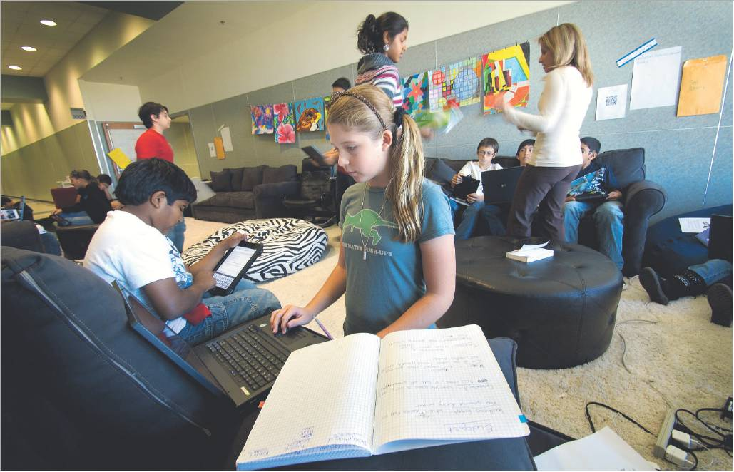

Robert W. Hart/Special Contributor
Seventh-graders Hannah Caracalas (center) and Abel Abraham (left) work on their assignments in the “learning lounge” at Killian Middle School in Lewisville. Teachers must reserve the space provided by the school’s PTA.

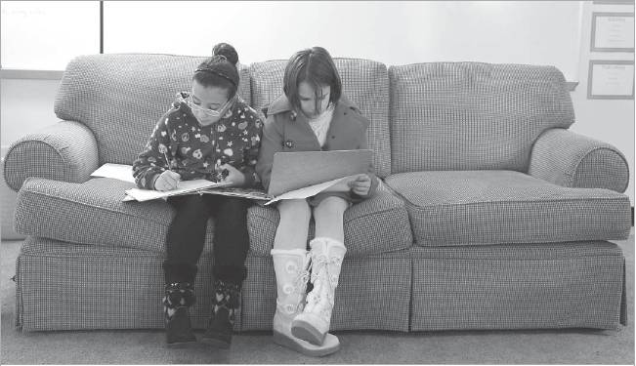
David Woo/Staff Photographer
Jenna Safa (left) and Shelby Oakes share a sofa in Angela Hamm's third-grade class at Highland Village Elementary. The school refers to it as a “Starbucks” classroom.

Source: Page 1B of Tuesday, November 08, 2011 issue of The Dallas Morning News

