It all adds up to a new career
Out of work since ’08, father becomes a math teacher in McKinney
By ERIC AASEN
Staff Writer eaasen@dallasnews.com
McKINNEY — Business was drying up, so Chuck Shepard shut down his company that installed window treatments. He pulled his three kids out of day care and became a stay-at-home dad.
Three years later, he has a job. He’s a teacher.
“I couldn’t believe my good fortune,” said Shepard, who is teaching sixth-grade math at Cockrill Middle School in Mc-Kinney.
“I had been out of work for so long. You just get used to and anticipate more bad news. … It hit me that for the first time in several years, I was gainfully employed again.” Shepard, a McKinney resident, was featured in The Dallas Morning News in 2009 for a story about life as a stay-at-home dad. He had been without a full-time job since December 2008.
Shepard’s wife, a civil engineer, was the family’s sole financial provider. He took care of the kids, taking them to the park, teaching them the alphabet and singing nursery rhymes.
Shepard, who had a background in accounting and finance, tried looking for a job.
“There were just no jobs to be had,” he said.
Last year, a friend asked him: Have you considered teaching?
“It threw me for a loop,” he said.
The friend told Shepard that he had the patience and personality to be in the classroom. Shepard thought about it and consulted family and friends. He enrolled in an alternative certification program and completed his student teaching.
Shepard, 46, looked for jobs over the summer. But he couldn’t find anything.
“I had pretty much given up,” he said.
Then a friend told Shepard about a math teacher opening at Cockrill in McKinney ISD. The school had too many students and not enough teachers.
The school year was under way, but Shepard went through the interview process. In mid-September, he landed the job.
Principal Melinda DeFelice heard good things about Shepard from the school where he did his student teaching. But she said she also hired him because of his heart.
“We could tell in the interview with him that he truly loves kids and wants to make an impact,” she said.
One recent morning, Shepard stood in his classroom, discussing fractions. He spoke calmly as he led the class through math problems, asking students how to find common denominators.
“I don’t want any of you to think that this number was magic or that we guessed,” Shepard told the class. “I want you to see how we got to it.”
Later, students gathered in small groups to work on math problems.
Over just two months, Shepard’s teaching style has evolved. When he started, he gave more lectures. But he realized that it’s hard for kids to pay attention to a long talk. So he injects some variety by showing short video clips or talking about his family.
One wall of his classroom is covered with records, including those by Michael Jackson, Foreigner and Cyndi Lauper. He plans to bring in a record player, so students can play albums for good behavior. (“What’s an album?” the kids asked him. He had to explain.)
At first, putting the kids in groups scared him. Too much chaos, he thought. But, during his planning period, he visited other teachers and saw them make it work.
“They didn’t give them a secret potion or sprinkle some pixie dust on them,” he said. “They just did it.”
When Shepard isn’t teaching, he’s managing students. Shepard says the patience he gained as a stay-at-home dad has paid off. A girl complained about her itchy eyes, so he sent her to the nurse. A boy was acting up, so Shepard pulled him aside and quietly told him to pay attention.
His biggest challenge: getting up to speed after missing the first few weeks of school — and staying caught up. He has to grade assignments and tests, answer parents’ phone calls and emails, and prepare class lessons.
At the end of each day, Shepard is mentally exhausted.
But when he steps into the classroom, it’s all worth it.
“When you’re actually in front of the kids and you see them learning and you start to get a feel for the impact, hopefully positive, that you’re having on them,” Shepard said, “it really is a rush to be up there teaching.”

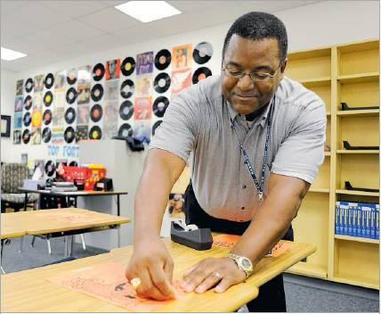

Matt Strasen/Special Contributor
Charles Shepard, preparing his classroom at Cockrill Middle School in McKinney, was told by a friend that he had the patience and personality to be a teacher.

Source: Page 1B of Saturday, November 12, 2011 issue of The Dallas Morning News

