ROMEO AND JULIET
ONCE upon a time there lived in Verona two great families named Montagu and Capulet. They were both rich, and I suppose they were as sensible, in most things, as other rich people. But in one thing they were extremely silly. There was an old, old quarrel between the two families, and instead of making it up like reasonable folks, they made a sort of pet of their quarrel, and would not let it die out. So that a Montagu wouldn't speak to a Capulet if he met one in the street—nor a Capulet to a Montagu—or if they did speak, it was to say rude and unpleasant things, which often [106] ended in a fight. And their relations and servants were just as foolish, so that street fights and duels and uncomfortablenesses of that kind were always growing out of the Montagu-and-Capulet quarrel.
Now Lord Capulet, the head of that family, gave a party—a grand supper and a dance—and he was so hospitable that he said anyone might come to it except (of course) the Montagues. But there was a young Montagu named Romeo, who very much wanted to be there, because Rosaline, the lady he loved, had been asked. This lady had never been at all kind to him, and he had no reason to love her; but the fact was that he wanted to love somebody, and as he hadn't seen the right lady, he was obliged to love the wrong one. So to the Capulet's grand party he came, with his friends Mercutio and Benvolio.
Old Capulet welcomed him and his two friends very kindly—and young Romeo moved about among the crowd of courtly folk dressed in their velvets and satins, the men with jeweled sword hilts and collars, and the ladies with brilliant gems on breast and arms, and stones of price set in their bright [107] girdles. Romeo was in his best too, and though he wore a black mask over his eyes and nose, everyone could see by his mouth and his hair, and the way he held his head, that he was twelve times handsomer than anyone else in the room.
Presently amid the dancers he saw a lady so beautiful and so lovable that from that moment he never again gave one thought to that Rosaline whom he had thought he loved. And he looked at this other fair lady, as she moved in the dance in her white satin and pearls, and all the world seemed vain and worthless to him compared with her. And he was saying this, or something like it, when Tybalt, Lady Capulet's nephew, hearing his voice, knew him to be Romeo. Tybalt, being very angry, went at once to his uncle, and told him how a Montagu had come uninvited to the feast; but old Capulet was too fine a gentleman to be discourteous to any man under his own roof, and he bade Tybalt be quiet. But this young man only waited for a chance to quarrel with Romeo.
In the meantime Romeo made his way to the fair lady, and told her in sweet words that he loved [108] her, and kissed her. Just then her mother sent for her, and then Romeo found out that the lady on whom he had set his heart's hopes was Juliet, the daughter of Lord Capulet, his sworn foe. So he went away, sorrowing indeed, but loving her none the less.
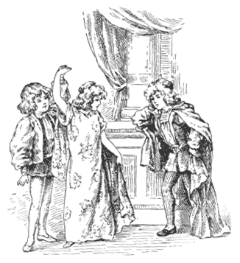
ROMEO DISCOVERS JULIET.
Then Juliet said to her nurse:
"Who is that gentleman that would not dance?"
[109] "His name is Romeo, and a Montagu, the only son of your great enemy," answered the nurse.
Then Juliet went to her room, and looked out of her window, over the beautiful green-grey garden, where the moon was shining. And Romeo was hidden in that garden among the trees—because he could not bear to go right away without trying to see her again. So she—not knowing him to be there—spoke her secret thought aloud, and told the quiet garden how she loved Romeo.
And Romeo heard and was glad beyond measure. Hidden below, he looked up and saw her fair face in the moonlight, framed in the blossoming creepers that grew round her window, and as he looked and listened, he felt as though he had been carried away in a dream, and set down by some magician in that beautiful and enchanted garden.
"Ah—why are you called Romeo?" said Juliet. "Since I love you, what does it matter what you are called?"
"Call me but love, and I'll be new baptized—henceforth I never will be Romeo," he cried, stepping into the full white moonlight from the shade [110] of the cypresses and oleanders that had hidden him. She was frightened at first, but when she saw that it was Romeo himself, and no stranger, she too was glad, and, he standing in the garden below and she leaning from the window, they spoke long together, each one trying to find the sweetest words in the world, to make that pleasant talk that lovers use. And the tale of all they said, and the sweet music their voices made together, is all set down in a golden book, where you children may read it for yourselves some day.
And the time passed so quickly, as it does for folk who love each other and are together, that when the time came to part, it seemed as though they had met but that moment—and indeed they hardly knew how to part.
"I will send to you to-morrow," said Juliet.
And so at last, with lingering and longing, they said good-bye.
Juliet went into her room, and a dark curtain hid her bright window. Romeo went away through the still and dewy garden like a man in a dream.
The next morning, very early, Romeo went to [111] Friar Laurence, a priest, and, telling him all the story, begged him to marry him to Juliet without delay. And this, after some talk, the priest consented to do.
So when Juliet sent her old nurse to Romeo that day to know what he purposed to do, the old woman took back a message that all was well, and all things ready for the marriage of Juliet and Romeo on the next morning.
The young lovers were afraid to ask their parents' consent to their marriage, as young people should do, because of this foolish old quarrel between the Capulets and the Montagues.
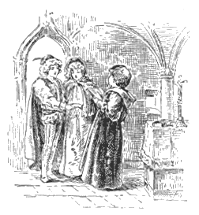
MARRIAGE OF ROMEO AND JULIET.
And Friar Laurence was willing to help the young lovers secretly, because he thought that when [112] they were once married their parents might soon be told, and that the match might put a happy end to the old quarrel.
So the next morning early, Romeo and Juliet were married at Friar Laurence's cell, and parted with tears and kisses. And Romeo promised to come into the garden that evening, and the nurse got ready a rope-ladder to let down from the window, so that Romeo could climb up and talk to his dear wife quietly and alone.
But that very day a dreadful thing happened.
Tybalt, the young man who had been so vexed at Romeo's going to the Capulet's feast, met him and his two friends, Mercutio and Benvolio, in the street, called Romeo a villain, and asked him to fight. Romeo had no wish to fight with Juliet's cousin, but Mercutio drew his sword, and he and Tybalt fought. And Mercutio was killed. When Romeo saw that this friend was dead, he forgot everything except anger at the man who had killed him, and he and Tybalt fought till Tybalt fell dead.
So, on the very day of his wedding, Romeo killed [113] his dear Juliet's cousin, and was sentenced to be banished. Poor Juliet and her young husband met that night indeed; he climbed the rope-ladder among the flowers, and found her window, but their meeting was a sad one, and they parted with bitter tears and hearts heavy, because they could not know when they should meet again.
Now Juliet's father, who, of course, had no idea that she was married, wished her to wed a gentleman named Paris, and was so angry when she refused, that she hurried away to ask Friar Laurence what she should do. He advised her to pretend to consent, and then he said:
"I will give you a draught that will make you seem to be dead for two days, and then when they take you to church it will be to bury you, and not to marry you. They will put you in the vault thinking you are dead, and before you wake up Romeo and I will be there to take care of you. Will you do this, or are you afraid?"
"I will do it; talk not to me of fear!" said Juliet. And she went home and told her father she would marry Paris. If she had spoken out and told her [114] father the truth . . . well, then this would have been a different story.
Lord Capulet was very much pleased to get his own way, and set about inviting his friends and getting the wedding feast ready. Everyone stayed up all night, for there was a great deal to do, and very little time to do it in. Lord Capulet was anxious to get Juliet married because he saw she was very unhappy. Of course she was really fretting about her husband Romeo, but her father thought she was grieving for the death of her cousin Tybalt, and he thought marriage would give her something else to think about.
Early in the morning the nurse came to call Juliet, and to dress her for her wedding; but she would not wake, and at last the nurse cried out suddenly—
"Alas! alas! help! help! my lady's dead! Oh, well-a-day that ever I was born!"
Lady Capulet came running in, and then Lord Capulet, and Lord Paris, the bridegroom. There lay Juliet cold and white and lifeless, and all their weeping could not wake her. So it was a burying that day instead of a marrying. Meantime Friar [115] Laurence had sent a messenger to Mantua with a letter to Romeo telling him of all these things; and all would have been well, only the messenger was delayed, and could not go.
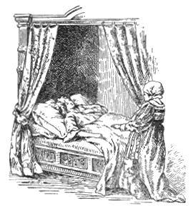
THE NURSE THINKS JULIET DEAD.
But ill news travels fast. Romeo's servant who knew the secret of the marriage, but not of Juliet's pretended death, heard of her funeral, and hurried to Mantua to tell Romeo how his young wife was dead and lying in the grave.
"Is it so?" cried Romeo, heart-broken. "Then I will lie by Juliet's side to-night."
And he bought himself a poison, and went straight back to Verona. He hastened to the tomb where Juliet was lying. It was not a grave, but a [116] vault. He broke open the door, and was just going down the stone steps that led to the vault where all the dead Capulets lay, when he heard a voice behind him calling on him to stop.
It was the Count Paris, who was to have married Juliet that very day.
"How dare you come here and disturb the dead bodies of the Capulets, you vile Montagu?" cried Paris.
Poor Romeo, half mad with sorrow, yet tried to answer gently.
"You were told," said Paris, "that if you returned to Verona you must die."
"I must indeed," said Romeo. "I came here for nothing else. Good, gentle youth—leave me! Oh, go—before I do you any harm! I love you better than myself—go—leave me here—"
Then Paris said, "I defy you, and I arrest you as a felon," and Romeo, in his anger and despair, drew his sword. They fought, and Paris was killed.
As Romeo's sword pierced him, Paris cried—
"Oh, I am slain! If thou be merciful, open the tomb, and lay me with Juliet!"
[117] And Romeo said, "In faith I will."
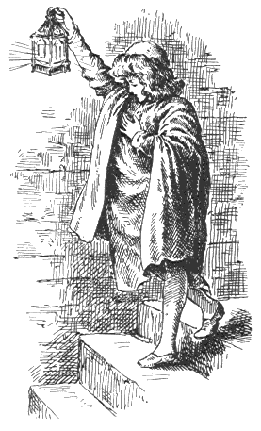
ROMEO ENTERING THE TOMB.
And he carried the dead man into the tomb and laid him by the dear Juliet's side. Then he kneeled by Juliet and spoke to her, and held her in his arms, and kissed her cold lips, believing that she was dead, while all the while she was coming nearer and nearer to the time of her awakening. Then he drank the poison, and died beside his sweetheart and wife.
Now came Friar Laurence when it was too late, and saw all that had hap- [118] pened—and then poor Juliet woke out of her sleep to find her husband and her friend both dead beside her.
The noise of the fight had brought other folks to the place too, and Friar Laurence, hearing them, ran away, and Juliet was left alone. She saw the cup that had held the poison, and knew how all had happened, and since no poison was left for her, she drew her Romeo's dagger and thrust it through her heart—and so, falling with her head on her Romeo's breast, she died. And here ends the story of these faithful and most unhappy lovers.

* * * * * * *
And when the old folks knew from Friar Laurence of all that had befallen, they sorrowed exceedingly, and now, seeing all the mischief their wicked quarrel had wrought, they repented them of it, and over the bodies of their dead children they clasped hands at last, in friendship and forgiveness.

