NBA LABOR AGREEMENT
Deal made for merry Mavs Christmas
Champs to get rings, play Heat in opener if accord ratified
By EDDIE SEFKO
Staff Writer esefko@dallasnews.com
The Associated Press
The NBA is back, and the Mavericks can start the countdown to raising their championship banner and slipping on their rings.
After five months of bickering, representatives of the owners and players put in a marathon negotiating session that ended about 2:30 a.m. Saturday with a tentative agreement on a new labor deal. It must be ratified in a vote by players and owners.
The season is set to start Christmas Day, with a marquee tripleheader built around the Mavericks’ home game against the Miami Heat.
That rematch of the NBA Finals, which the Mavericks won in six games on June 12, will include Commissioner David Stern presenting the Mavericks with their championship rings, along with the unveiling of the banner.
The league would play a 66-game regular season, 16 fewer than usual. Training camps would open Dec. 9 — as what will no doubt be a frantic free-agency period — and an abbreviated preseason, probably with two to four exhibitions, would be played before the regular season begins.
“I’m obviously very happy that the ball will be bouncing soon,” Mavericks forward Dirk Nowitzki said Saturday. “We all know what was at stake, and it’s great that we’re going to have an NBA season. Hopefully, we can make it another great one.”
Mavericks owner Mark Cuban and all team personnel are prohibited from commenting on the season or the lockout until the dispute is officially resolved.
Since the lockout began July 1, the season has been in jeopardy. Stern, deputy commissioner Adam Silver and a team of lawyers representing the owners have been negotiating with Billy Hunter, executive director of the NBA Players Association, Derek Fisher, president of the association, and their legal representatives.
After hundreds of hours of fruitless talks, Stern said Nov.14 that the league was headed for a “nuclear winter.”
The sides reconvened Friday and talked for 15 hours before emerging in New York with an agreement in principle. A simple majority is needed by players and owners, and the votes could take place early this week.
“We’ve reached a tentative understanding that is subject to a variety of approvals and very complex machinations,” Stern said. “But we’re optimistic that will all come to pass, and the NBA season will begin on Dec. 25.”
After the three games on Christmas, the rest of the schedule will be reconfigured.
The key negotiating points for getting a deal included the players agreeing to a sliding share of basketball-related income, which will give them between 49 percent and 51 percent of the revenue. Players received 57 percent under the last collective bargaining agreement.
The owners also got what they hope will be a more restrictive system of free agency for big-spending teams that are over the luxury-tax threshold.
“I think it will largely prevent the high-spending teams from competing in the free-agent market in the way they’ve been able to in the past,” Silver said. “It’s a com promise. It’s not the system we sought in terms of a hard [salary] cap, but the luxury tax is harsher than it was in the past deal. We feel, ultimately, it will give fans in every community hope that their team can compete for championships.”
The players, meanwhile, kept many of the free-agent components that were important to them.
“We’re going to turn it all over to the lawyers and have them work out the details,” said Hunter, who added that it could take a week to re-form the players’ union, which had disbanded in an effort to push the negotiations into a courtroom.
With both sides uncertain about their chances for success in a court battle, calmer heads prevailed during the Thanksgiving weekend, and a season is on the way, albeit starting 55 days after originally scheduled.
“We’re excited for the fans,” said San Antonio owner Peter Holt, chairman of the league’s labor relations committee. “We’re excited to start playing basketball, for players, for everybody involved.”

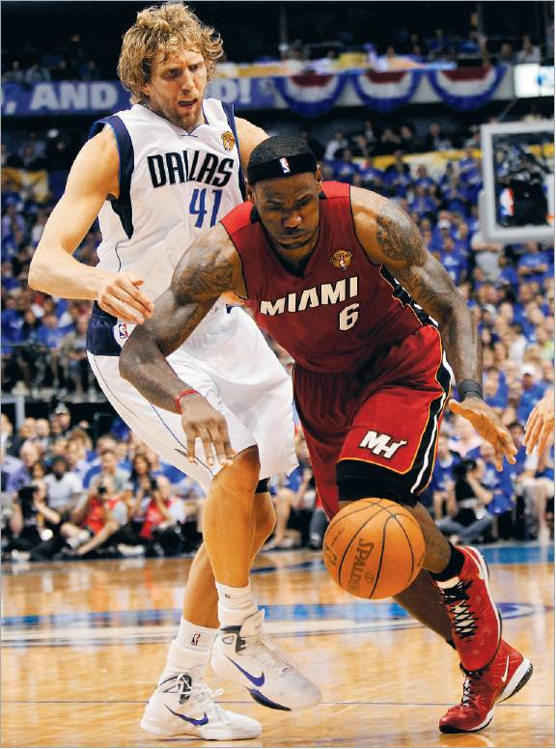
Louis DeLuca/Staff Photographer
Dirk Nowitzki (left) and LeBron James, in last season’s NBA Finals, will be facing off again Christmas Day in the regular-season opener if the deal is ratified.

Source: Dallas Morning News Page 1A Sunday, November 27, 2011

