HEALTH
Truckers driven to shape up
Schedules make it difficult, but many realizing crucial need for lifestyle changes
Abby Ellin, The New York Times
After driving hundreds of miles, the last thing Roy Williams, a truck driver from Denton, wanted to do was exercise. After a day trapped in the cab, stopping only to gorge on greasy fare at truck stops, who could think of working out?
But once he ballooned to 405 pounds, he knew he had to make a change. So last year, Williams, 58, did something rare for someone in his profession: He embarked on a diet and exercise program.
The six-pack of Coca-Cola he drank each day? Gone. The hamburgers, chips and chocolate he relished? No more. Today, he drinks a protein shake mixed with ice water or soy milk for breakfast, nibbles cantaloupe and red grapes, and makes “sandwiches” with thinly sliced meat and cheese but no bread. He keeps a fold-up bike in his truck and zips around rest areas on his breaks.
His weight is down to 335 pounds, and he’s managed to reduce the amount of blood pressure medication he takes. “I rarely, maybe once a week, even go into a truck stop,” said Williams, who has been navigating an 18-wheeler for 30 years.
Williams’ predicament is hardly unique. On the road for weeks on end, with the sorts of diets that make nutritionists apoplectic, the nation’s truckers are in pretty bad shape. Now, beset by rising insurance costs and desperate to ensure that their drivers pass government health tests, trucking companies and industry groups are working hard to persuade road warriors to change their habits.
While concern for driver health is certainly a force behind the wellness initiatives, economics also plays a role. The trucking industry is grappling with sky-high insurance rates and rising medical costs. The 2010 Cottingham and Butler Trucking Compensation and Benefits Benchmark Survey, an annual report for the industry, found that deductibles and out-of-pocket costs to truck drivers and their employers are 40 to 70 per cent higher than in other industries.
“Obesity is a terrible problem in the trucking industry,” said Brett Blowers, director of marketing and development for the Healthy Trucking Association of America, an industry organization in Montgomery, Ala.
A few years ago, Blowers’ group conducted a blood pressure screening of more than 2,000 drivers at an annual truck show. “We sent 21 directly to the emergency room, and one of them had a heart attack on the way there,” he recalled.
The U.S. Transportation Department requires truck drivers to pass a certifying medical exam every two years. Drivers are checked for severe heart conditions, high blood pressure and respiratory maladies, including sleep disorders.
While the statistics are bleak, they’re not especially surprising. Driving is a sedentary activity. Most truckers are paid by the mile, so they tend to squeeze out every last second of the 11 hours they’re allowed on the road in a 24-hour period.
“Some days I’ve driven 600 miles and didn’t even stop,” said Barb Waugh, 58, of Fairfax, S.D., one of an estimated 190,000 female truckers. In a typical week, she logs 2,500 to 4,000 miles. “I feel like a marshmallow because I don’t get to exercise,” said Waugh, who weighs about 300 pounds.
Routines that keep other Ameri cans healthy — hitting the gym, cooking at home, scheduling a doctor’s appointment — are nearly impossible, since drivers are rarely in one place for more than a day or two. The only exercise for many is pressing the gas pedal; most don’t load and unload cargo.
When they do leave their vehicles, it’s usually at truck stops and fast-food restaurants where nearly every option is greasy or fatty or served up in calorie-rich buffets — which some truckers say stands for “Big Ugly Fat Fellows Eating Together.”
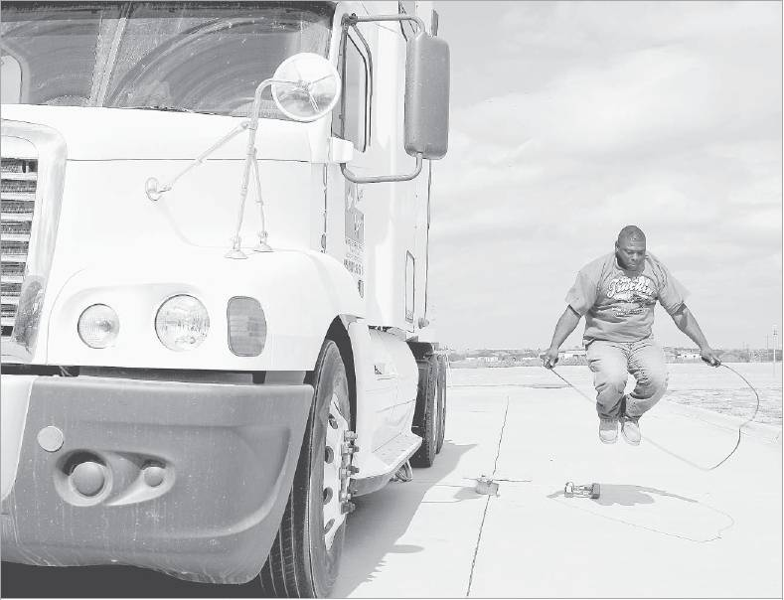
Truck driver Oran Clay jumped rope last month during Driver Appreciation Day at Texas Star Express in Rockwall. Routines that keep other Americans healthy are nearly impossible for always-on-the-go drivers.
Khampha Bouaphanh/The New York Times

Source: Page 1 A, Dallas Morning News, November 27, 2011

