Exotic-animal laws too tame, groups say
Bill Ruthhart, Chicago Tribune
ROCK SPRINGS, Wis. — Tucked amid the high bluffs of central Wisconsin, this town of 361 people appears to be like most others, with two old taverns, a gas station and community center dotting its main drag.
But just up the hill, at the end of Pine Street, is the unexpected — a farmhouse with security cameras overlooking a barbed-wire fenced perimeter filled with 19 Bengal and Siberian tigers, six African and Atlas lions, four leopards and an African serval.
Such is the world of exotic animals in the U.S., where in any barn, horse trailer — even bathtub — can be found the planet’s most dangerous and poisonous species, native to areas half a globe away.
Most of these animals draw little attention, but the decision last month of a Zanesville, Ohio, man to cut free his 56 exotic animals before committing suicide has brought fresh, high-profile scrutiny on exotic-animal owners that experts call more intense than ever.
That rural scene in Ohio — with police using side arms and sniper rifles to hunt tigers, lions and leopards — has drawn nationwide outrage, fueling a push from animal rights organizations calling for not just Ohio, but several states, to strengthen exotic-animal laws.
While those groups have targeted states with weak laws, such as Wisconsin, they consider Illinois to have a strong ban on the animals. But there are exceptions to Illinois’ ban — not only for zoos and research cen ters, but private owners who have a federal permit to exhibit animals.
Illinois cases have included the escape of a tiger at a Bloomington truck stop, a Burmese python found in a Rockford parking lot, a 3-foot alligator swimming in the Chicago River, a man mauled to death by a bear at a Flora petting zoo and a man killed by his pet lion.
Experts say such isolated incidents — even cases when animals escape — draw attention that fades quickly. But the Zanesville incident has the staying power to drive change.
“I think absolutely this is going to cause a nationwide movement, because this has elevated the national consciousness about this issue,” said Adam Roberts, executive vice president of Born Free USA, a non profit organization that supports exotic animals, but opposes their sale and trade.
Jeff Kozlowski wants Wisconsin to do just that.
He and his fianceé, Jenny Meyer, own Wisconsin Big Cat Rescue, the refuge for 30 exotic cats that sits atop the hill in Rock Springs.
Kozlowski first became involved with exotic cats when he bought two lion cubs and a tiger cub. He made up to $300 an hour taking them to attractions around Wisconsin Dells, charging tourists to have pictures taken with the cubs.
But Kozlowski said he quickly saw how stressful the experience was on the animals and quit after two months.
Kozlowski has run his refuge ever since. He considers his sanctuary at capacity, but that hasn’t stopped an estimated 10 calls per year from owners pleading for him to take their tigers or lions.
“Every year around September or October, I get calls from people with 4-month-old cubs,” he said. “They’re done taking pictures with them and don’t want to take care of them for the next15 or 20 years.”
Those calls prompted Kozlowski to push for a new Wisconsin law in 2007 that would have restricted breeding and banned cub pictures, but the bill failed.
Now, he is trying again, hoping the Zanesville incident will create a sense of urgency.
Kozlowski said he is working with the Animal Legal Defense Fund to propose legislation that not only would ban the pictures, but also dictate the size of animal enclosures, force owners to register their animals with the state and require those with dangerous animals to notify local police.
Scott Shoemaker said there is no need for new laws. He is director of Responsible Exotic Animal Ownership, a Nevada group that offers guidelines for exotic-animal enthusiasts while fighting attempts to limit ownership.
“We knew the animal rights people would use this incident to push their mission for laws, but this was a lone act of a very troubled person that could have happened anywhere,” said Shoemaker.

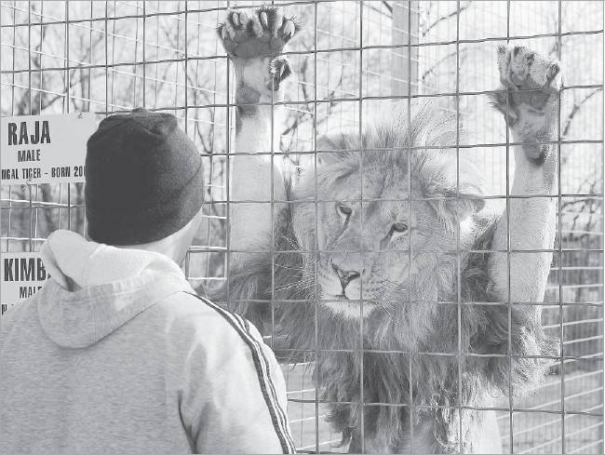
Nancy Stone/Chicago Tribune
Jeff Kozlowski checks on Kimba at Wisconsin Big Cat Rescue in Rock Springs. He says his sanctuary is at capacity but gets calls from owners asking him to take tigers or lions.

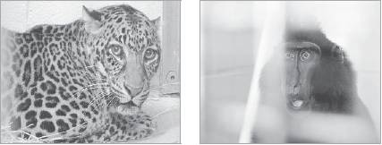

Source: Page 12A of Sunday, November 06, 2011 issue of The Dallas Morning News

