EAST TEXAS
Wiley debate team ready for historic rematch
Schools featured in movie have changed since ’35 competition
By JAMES RAGLAND
Staff Writer jragland@dallasnews.com

Cary Chavis knows the stakes will be high when he takes the stage Friday night for a historic debate at Wiley College in Marshall.
He tries to block out the hype, he said, so the symbolic weight of the moment doesn’t overwhelm him.
“But it really kind of puts everything into perspective — the school’s legacy, the country’s history, the significance of what happened in 1935,” said the senior debate captain.
That’s the year Wiley, a small historically black college, knocked off the University of Southern California’s top-ranked debate team.
On Friday, nearly 77 years after Wiley’s stunning victory, the two schools will face each other again in Marshall.
But this time, rather than a black duo facing a white one, both squads will project just how different America is today.
The Wiley team features a white male from Houston and Chavis, who is black, from Lake Charles, La. USC’s exhibition team boasts two females, one white and the other with roots in India.
“Back in 1935, it was interesting because we left the building as equals. And this time, we’re entering the building as equals,” said Christopher Medina, the school’s director of forensics.
It’s a poignant moment in history for Wiley, which revived its moribund debate team in 2008, the year after the school was featured in the 2007 Denzel Washington movie The Great Debaters.
Washington and other donors gave the school roughly $1.5 million to resuscitate the forensics program.
When the schools first met, the country was deeply “divided by a color line,” noted Dr. Haywood L. Strickland, president and chief executive officer of Wiley.
“I am proud that all these years later, these schools will meet in a country that celebrates differences, knows that skin color is no determinant of intelligence and recognizes that we share a common humanity,” Strickland said.
That was not the case when Melvin B. Tolson — a young, black English professor — first assembled Wiley’s powerhouse debate teams in the 1930s.
His squads gained a hard-earned reputation for being unbeatable, and many schools were afraid to face them.
Given the country’s racial segregation at the time, the Wiley team members typically packed themselves into an older-model car, traveling along back roads and streets to reach their destinations. They avoided white-owned hotels and restaurants that forbade them.
For students of history, the social context in which the victory occurred makes Wiley’s upset win over USC all the more significant — and adds extra symbolic importance to Friday’s reunion.
“This is an incredible opportunity to pay homage to this historic debate and these individuals who overcame great adversity to become champions,” said Medina.
Fast-forward to 2012 and one now finds a Wiley College that’s emphasizing diversity, as evidenced by the mixed team that will take the stage on Friday and the Hispanic debate coach recently hired to direct it.
“I had other offers to go to other schools,” said Chad Mossman, a senior from Houston and the only white debater at Wiley. “But I wanted to go somewhere that was different, unique.”
Mossman, a business student, hopes to go to law school when he graduates from Wiley, a place, he said, where he’s been warmly embraced by his peers and professors.
He said attending Wiley and joining the debate team has been a great experience. “I have never regretted it,” Moss-man said.
That is a familiar refrain heard around the Wiley campus these days, thanks in large part to the Denzel Washington flick, which reminded America of the significant role and achievements of historically black colleges and universities.
Wiley, a liberal arts college founded in 1873 by the Freedman’s Aid Society of the Methodist Episcopal Church to educate “newly freed men,” had been in decline in recent years. The college, however, was just beginning to rebound when Hollywood came calling.
Washington’s $1 million gift to the school, combined with roughly half a million dollars in pledges from other donors, helped get the debate program off the ground and fueled the school’s revival.
Chavis saw The Great Debaters with his family on Christmas Day in 2007. He was so moved by the film that he decided Wiley was where he needed to be.
“I didn’t know about the Denzel Washington money until I got here,” said Chavis, whose debating skills helped earn him a full scholarship.
The Wiley team ranked in the top 10 in the 2011 Pi Kappa Delta National Tournament and third in debate sweepstakes, said Medina.
For Chavis, who has participated in “80 to 100 debates” over the past four years, none has more symbolic weight than the upcoming debate against USC.
And no matter which team prevails in its argument, with Wylie debaters poised to argue affirmatively that “Civil Disobedience is Necessary in Order to Achieve Legitimacy,” Chavis offers this insight:
“It won’t be another 77 years before we do it again.”
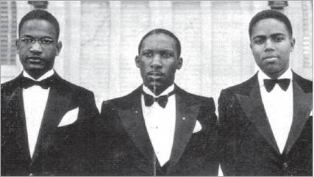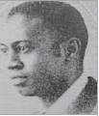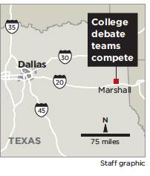
Wiley College MELVIN B. TOLSON
From left: The 1935 debate team at Wiley College assembled Wiley’s 1930s teams
consisted of Hobart Jarrett, Henry Heights and James Farmer Jr.

