ALPHA Bus Information for 2015 – 2016 School Year
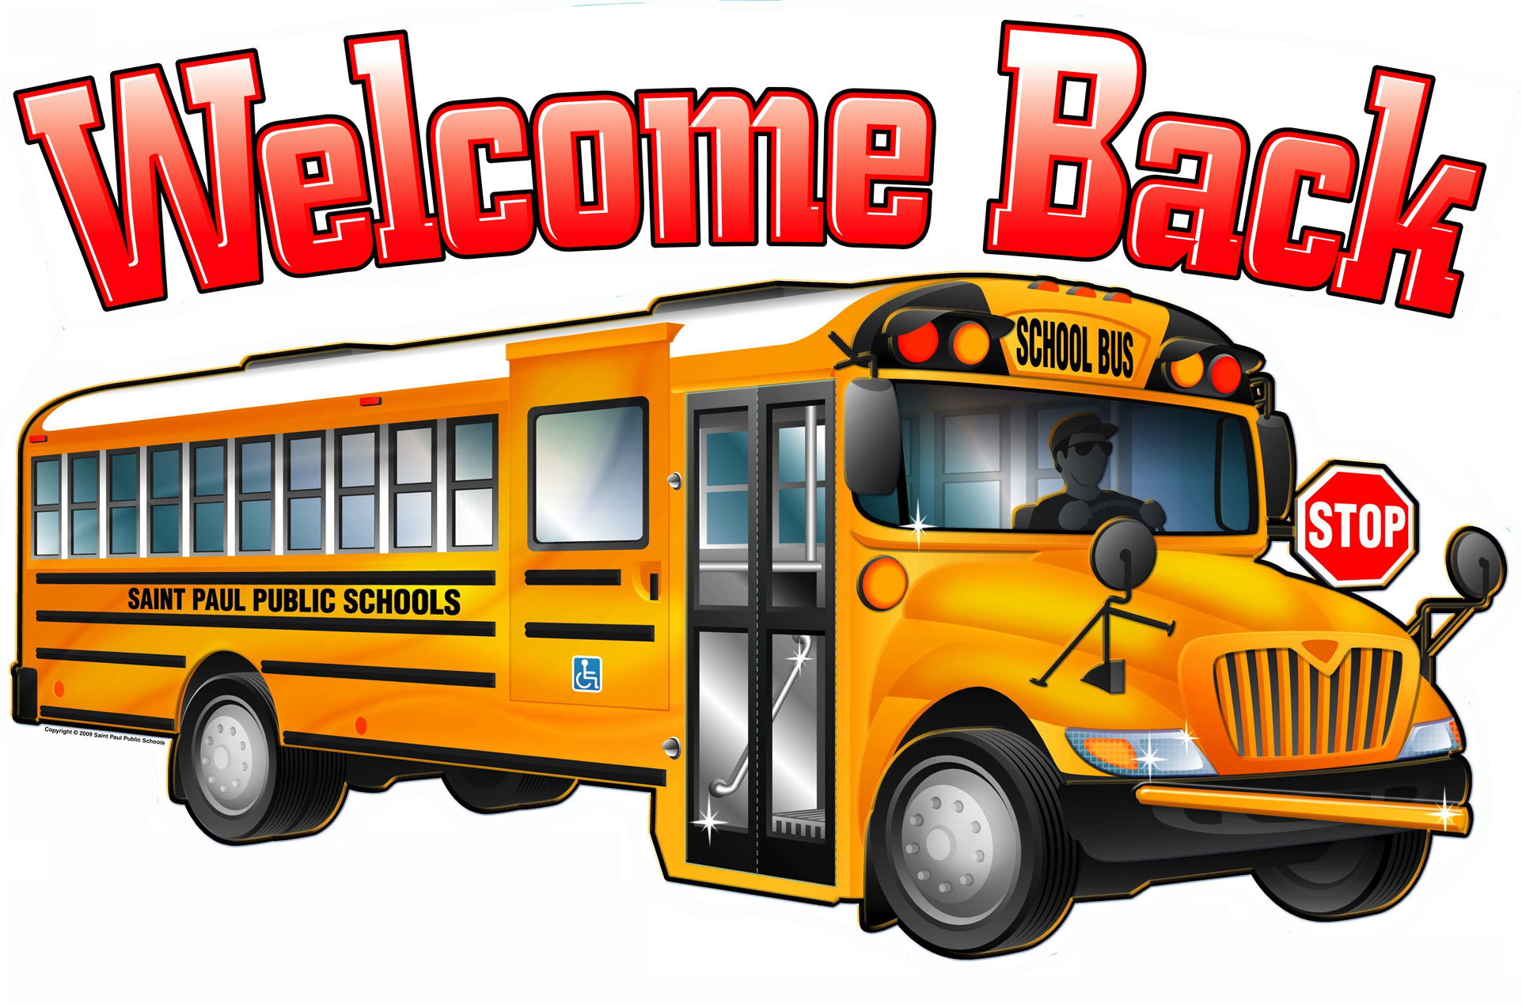
Durham Transportation will transport one set of 4th and 5th graders to Webb on Monday and Tuesday and the other set on Wednesday and Thursday. Parents are asked to have their students at the home campus by 8:00. Students arriving after the bus has left, will either be transported to Webb by their parents, or remain at the home campus for that day.

The 4th and 5th grade classes will depart at 1:30, so that students may load the buses and make it back to their home campuses for specials and dismissal.

If you need any further information, please contact:
Karen J. Green, M.Ed., Coordinator of Gifted and Talented K-12, kjgreen@mckinneyisd.net

