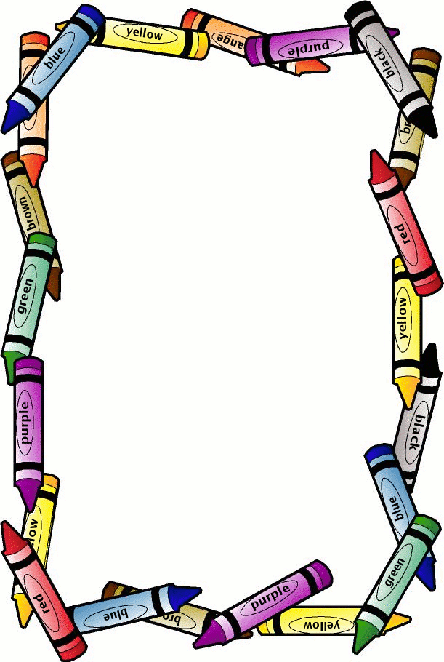

3rd Grade

ALPHA Supply List

* 1 pocket folder with brads
* 2 dozen pre-sharpened #2 pencils
* 1 composition notebook
* 1 tri-fold board
* 1 container of Clorox wipes
* 1 package of mini hot glue sticks